**SECTION A (60 Marks)**

Answer only **three** questions from this section.

1. (i).What is meant by the term colligative property. (02 marks)

(ii).State any two colligative properties of a solution. (01 mark)

(iii).State any two limitations of colligative properties stated in (a) (iii) above. (02 marks)

1. Describe how molecular mass of cane sugar can be determined using the depression of freezing point method. (07 marks)
2. The table below shows the freezing points of various solutions of cane sugar in solvent Y.

|  |  |  |  |  |  |  |  |
| --- | --- | --- | --- | --- | --- | --- | --- |
| Mass of cane sugar[g/100g solvent Y] | 26 | 24 | 66 | 78 | 118 | 148 | 173 |
| Freezing point/ᵒC | 5.11 | 4.87 | 4.51 | 4.33 | 3.73 | 3.28 | 2.91 |

Plot a graph of freezing point against mass of cane sugar and use it to determine: (@02½ marks)

1. Freezing point of solvent Y.
2. Freezing point constant for solvent Y [RMM of cane sugar = 342]
3. State and explain how the freezing point of the solution would be affected if cane sugar associates in solvent Y. (02 marks)
4. Explain why the method of depression of freezing point is not suitable for determination of relative molecular mass of very large molecules. (01 mark)
5. An organic hydrocarbon, R on complete combustion yielded 13.20g of carbon dioxide gas and 2.70g of water. When 9.40g was vapourized at a temperature of 273K and a pressure of 760mmHg, it occupied a volume of 2.7 x 10-3m3.
6. Calculate the empirical formula of organic hydrocarbon, R. (02½ marks)
7. Determine the molecular formula of organic hydrocarbon, R. (03 marks)
8. Organic hydrocarbon, R burns with a sooty flame. Identify organic hydrocarbon, R. (01 mark)
9. Discuss the reactions of organic hydrocarbon, R with:
10. Bromine. (04 marks)
11. Propene. (04 marks)
12. Ethanoyl bromide. (04 marks)

[Your answer should include conditions for the reactions and mechanism for the reactions where possible]

1. Write equation to show how organic hydrocarbon, R can be synthesized from benzaldhyde: (01½ marks)
2. **What is meant by the following terms?**
3. Complex ion. (02 marks)
4. Oxidation State. (01 mark)
5. Explain why transition metals form complex ions. (02 marks)
6. Write the electronic configuration of zinc. (01 mark)
7. State two reasons why zinc is not considered as a typical transition element. (02 marks)
8. Chromium and iron are transition elements. State three properties that classify them as transition elements. (03 marks)
9. Give a reason why iron (III) compounds are more stable than iron (II) compounds. (01 mark)
10. Describe the reactions of chromium with: (@02 marks)
11. Water.
12. Oxygen.
13. Chlorine.

[Your description should include relevant equations]

1. **What is meant by the term degree of dissociation?** (02 marks)
2. State and explain any two factors which affect the degree of dissociation of an electrolyte. (03 marks)
3. Define the term solubility product. (01 mark)
4. The solubility product of aluminium hydroxide 1.6x10-33mol4dm-12. Calculate the solubility of aluminium hydroxide in:
5. Water. (02 marks)
6. 0.01M sodium hydroxide solution. (03 marks)
7. Explain your results in (d) (i) and (ii) above. (02 marks)
8. State two applications of solubility product. (01 mark)
9. Explain why zinc sulphide is precipitated by hydrogen sulphide from ammoniacal solution. (02 marks)
10. Describe an experiment to determine the solubility product of potassium iodate in water.

**SECTION B (40 Marks)**

Answer only **two** questions from this section.

1. (a).Define the term enthalpy of neutralization. (02 marks)
2. Briefly explain how the enthalpy of neutralization between hydrochloric acid and sodium hydroxide solution can be determined. (05 marks)
3. Define the term standard enthalpy of reaction. (02 marks)
4. Excess zinc was added to 25cm3 of 1M copper (II) sulphate solution in a plastic beaker and temperature of the solution recorded at some time intervals. The data is shown below.

|  |  |  |  |  |  |  |
| --- | --- | --- | --- | --- | --- | --- |
| Time (Minutes) | 0 | 2.5 | 3.0 | 5.0 | 6.0 | 7.0 |
| Temperature (ᵒC) | 27.2 | 66.0 | 69.5 | 65.0 | 62.0 | 59.5 |

1. Plot a graph of temperature against time. (04 marks)
2. Use the graph to determine the molar enthalpy of the reaction. [Specific heat capacity of the solution = 4.2J/g/k]
3. Explain why hydrated copper (II) sulphate crystals dissolve endothermically while anhydrous copper (II) sulphate dissolves exothermically. (03 marks)
4. **(a). The elements fluorine, chlorine, bromine and iodine are in group (VII) of the periodic table.**
5. **State the physical state in which each of the above given elements exists at room temperature. (02 marks)**
6. **Explain your answer in (a) (i) above. (04 marks)**
7. **Discuss the reactions of the elements fluorine, chlorine, bromine and iodine with:**
8. Water. (05 mks) (ii) Sodium hydroxide solution.(07 marks)
9. How would you distinguish between potassium bromide and potassium iodide given chloride water and tetrachloromethane. (02 marks)
10. **Complete the following equations and outline the mechanism.**



1. Explain the following observations.
2. An aqueous solution of iron (III) chloride is acidic to litmus. (04 marks)
3. Nitrogen is a gas at room temperature where phosphosphorus is a solid at the same temperature yet both belong to the same group in the periodic table. (04 marks)
4. Benzene undergo electrophilic substitution reaction whereas cyclohexene undergo electrophilic addition reaction. (04 marks)
5. Iodine is much more soluble in potassium iodide solution than in water. (04 marks)
6. The acid dissociation constant, Ka of bromoethanoic acid is greater than that of ethanoic acid at the same temperature. (04 marks)

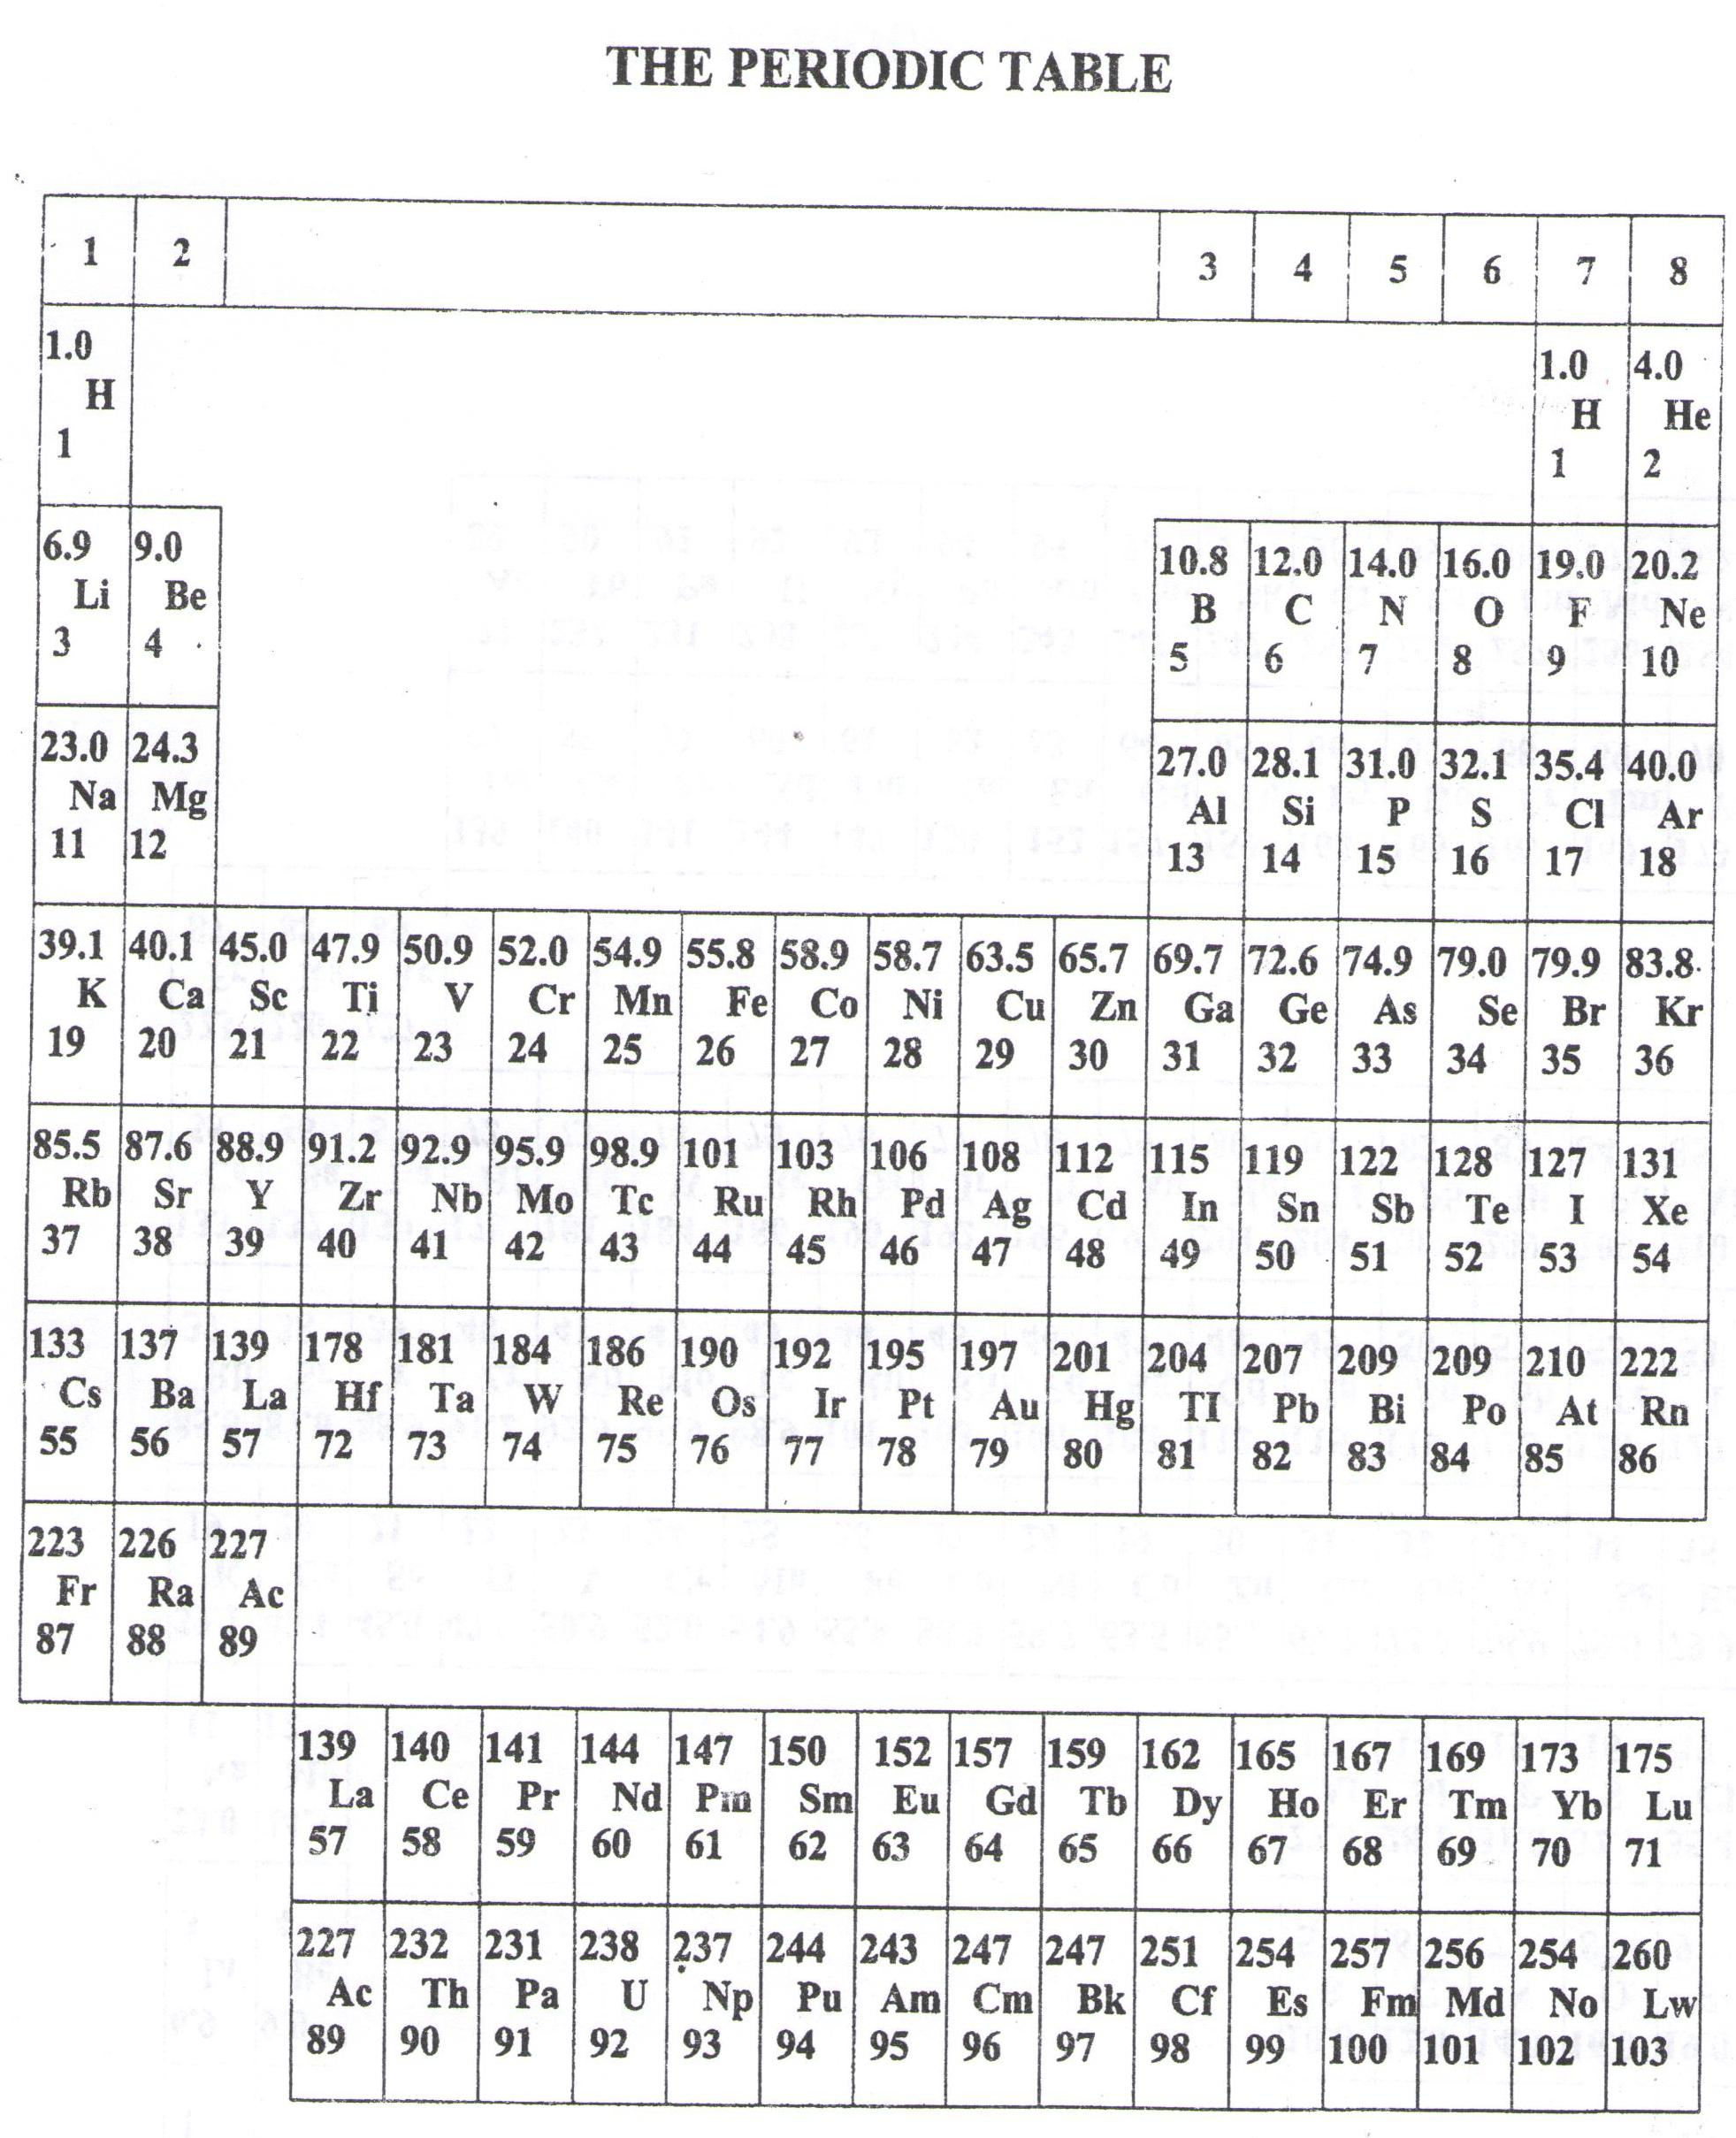

**Success = end**

WELCOME TO SENIOR SIX, YEAR 2023

This is the last page of the printed paper, Page 06